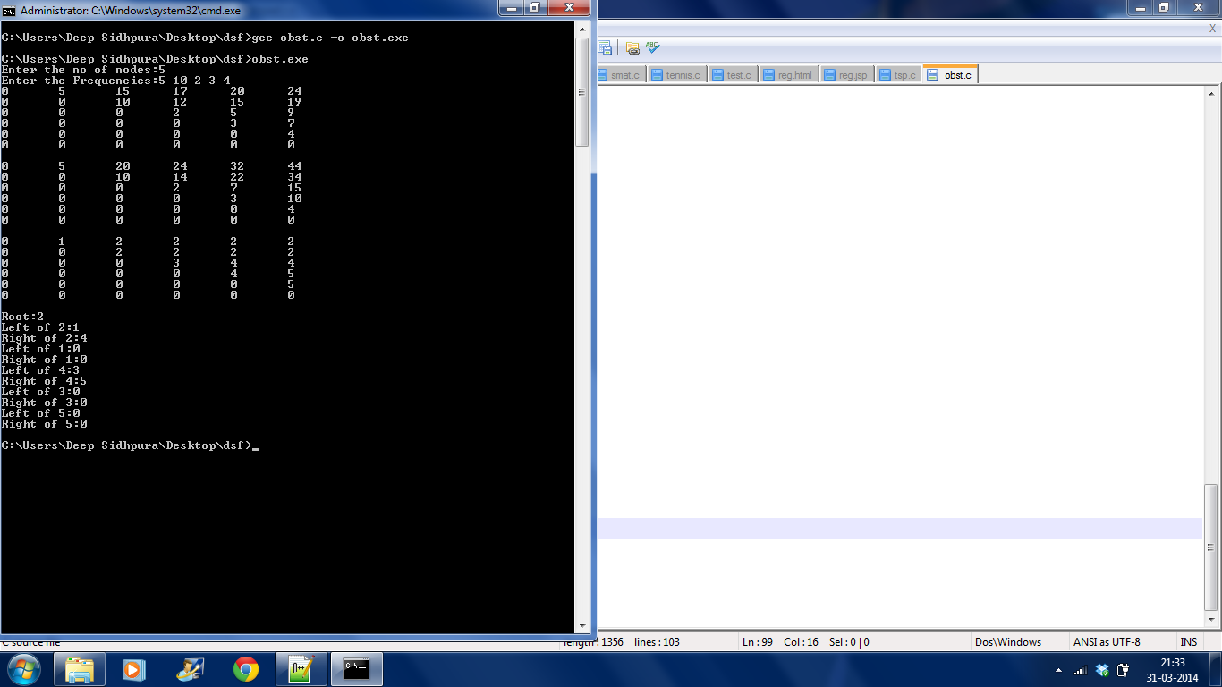

#include<stdio.h> //Deep Sidhpura

SE Computers Roll no 71

void btree(int R[10][10],int i,int j){

if(i==j){

//printf("Leaf node\n");

return;

}

else{

printf("Left of %d:%d\n",R[i][j],R[i][R[i][j]-1]);

printf("Right of %d:%d\n",R[i][j],R[R[i][j]][j]);

btree(R,i,R[i][j]-1);

btree(R,R[i][j],j);

}

}

void main(){

int F[10];

int P[10][10]={0,0},W[10][10]={0,0},R[10][10]={0,0};

int n;

int i,j,k;

int tempindex,min=1000,s,diff=2;

printf("Enter the no of nodes:");

scanf("%d",&n);

printf("Enter the Frequencies:");

for(i=1;i<=n;i++)

scanf("%d",&F[i]);

for(i=0;i<=n;i++){

for(j=0;j<=n;j++){

for(k=i+1;k<=j;k++){

P[i][j]+=F[k];

}

}

}

for(i=0;i<n;i++){

W[i][i+1]=F[i+1];

R[i][i+1]=i+1;

}

for(i=0;i<=n;i++){

for(j=0;j<=n;j++){

printf("%d\t",P[i][j]);

}

printf("\n");

}

i=0;

while(diff<=n){

j=i+diff;

for(k=i+1;k<=j;k++){

s=W[i][k-1] + W[k][j];

if(s<min){

min=s;

tempindex=k;

}

s=0;

}

W[i][j]=P[i][j]+min;

R[i][j]=tempindex;

i++;

min=1200;

if(i>(n-diff)){

i=0;

diff++;

}

}

printf("\n");

for(i=0;i<=n;i++){

for(j=0;j<=n;j++){

printf("%d\t",W[i][j]);

}

printf("\n");

}

printf("\n");

for(i=0;i<=n;i++){

for(j=0;j<=n;j++){

printf("%d\t",R[i][j]);

}

printf("\n");

}

printf("\nRoot:%d\n",R[0][n]);

btree(R,0,n);

}